INFORMATION MANAGEMENT

**Exercise 8**

1. How many unique salary packages does our company Bignet offer?

SELECT COUNT(DISTINCT salary) FROM employee_data;

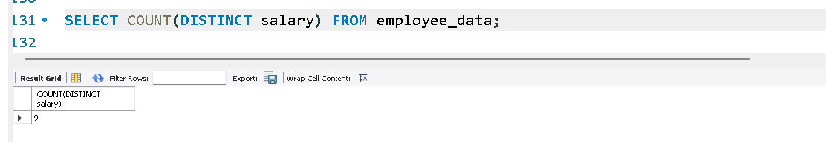

2. List the average age of employees working at Bignet.

SELECT AVG(age) FROM employee_data;

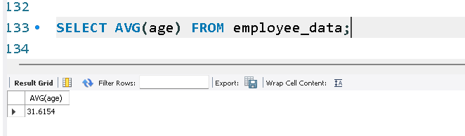

3. How many distinct first names do we have in our database?

SELECT COUNT(DISTINCT f_name) FROM employee_data;

